[FillAnyPDF](https://www.fillanypdf.com/)

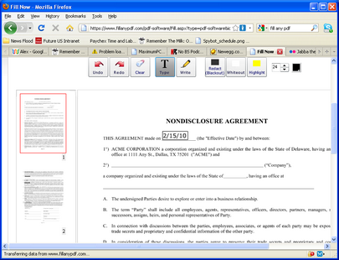

FillAnyPDF is a fairly simple web app which allows you to upload a PDF file, then easily write on it wherever you want. This allows you to easily fill out any form, even if they’re not in an editable PDF form. You can also share your blank form with others, so you can collect forms from a group easily. FillAnyPDF also supports electronic signatures and has a repository of free forms.

[Google Wave](http://www.maximumpc.com/wave.google.com/)

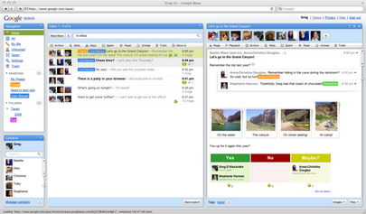

“What is Google Wave?”

That was the question a lot of people asked when Google launched its email-replacement-slash-collaboration platform Wave, and to a large extent, the question remains unanswered. What we do know is that it’s a online platform for users to participate in “Waves,” documents that can be edited in real-time by any invitee. Some uses are obvious (Waves are great for collaborating on articles and presentations) while others are more contentious (is a Wave better for regular communication than an email?). Despite the uncertainty, Wave is a web app with enormous potential, and we recommend everyone give it a try.

[SpeedTest](http://www.speedtest.net/)

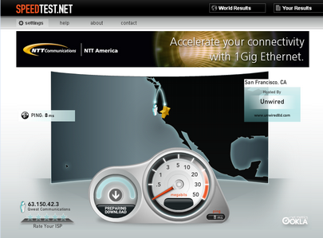

Everyone wonders sometimes why their ISP’s claim of Blazing Fast Internet doesn’t seem to translate to faster downloads or lower pings. But both of those situations involve a second party’s connection as well, so it’s difficult to tell exactly how fast your connection is. That’s where SpeedTest comes in handy. By letting you select a server near you, and showing you ping readings and download speeds to that server, SpeedTest gives you a quantifiable measure of your connection speed.

[Grooveshark](http://listen.grooveshark.com/)

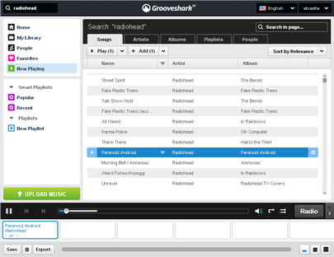

What makes Grooveshark special enough that we recommend it over the dozens of other music streaming web apps? Well, the biggest thing is the size of its library. You can find virtually any song on their site, ready to be played instantly, included in a playlist, or added to your personal library. Your library (available with a free account) allows you to select any number of songs from their larger list, which you can then browse through with an iTunes-like interface.  
Grooveshark has licensing agreements with some record companies, but its legality has nonetheless been called in to question. In other words, enjoy, but don’t get too attached.

[Vuvox](http://www.vuvox.com/)

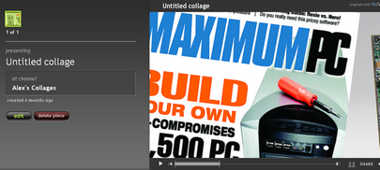

Vuvox is a rich media creation app that allows you to quickly turn your photos and audio into a moving web collage. A set of simple editing tools allow you to crop and rotate your pictures and when you’re done you can embed your collage into any webpage, or share links to a larger version on Vuvox’s website.

[Keep reading](http://www.maximumpc.com/article/features/30_incredible_web_apps_you_need_try?page=0%2C2) for more great web apps!

* [« Previous](http://www.maximumpc.com/article/features/30_incredible_web_apps_you_need_try?page=0,0)
* [1](http://www.maximumpc.com/article/features/30_incredible_web_apps_you_need_try?page=0,0)
* 2
* [3](http://www.maximumpc.com/article/features/30_incredible_web_apps_you_need_try?page=0,2)
* [4](http://www.maximumpc.com/article/features/30_incredible_web_apps_you_need_try?page=0,3)
* [5](http://www.maximumpc.com/article/features/30_incredible_web_apps_you_need_try?page=0,4)
* [6](http://www.maximumpc.com/article/features/30_incredible_web_apps_you_need_try?page=0,5)
* [» Next](http://www.maximumpc.com/article/features/30_incredible_web_apps_you_need_try?page=0,2)